Kubernetes Task-2

Step 1:

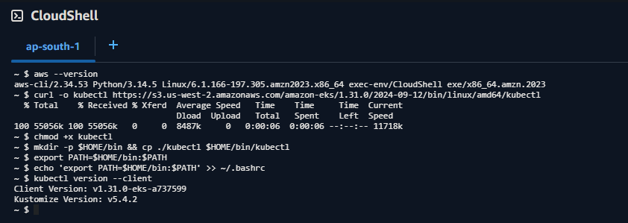

Step 2:

Step 3:

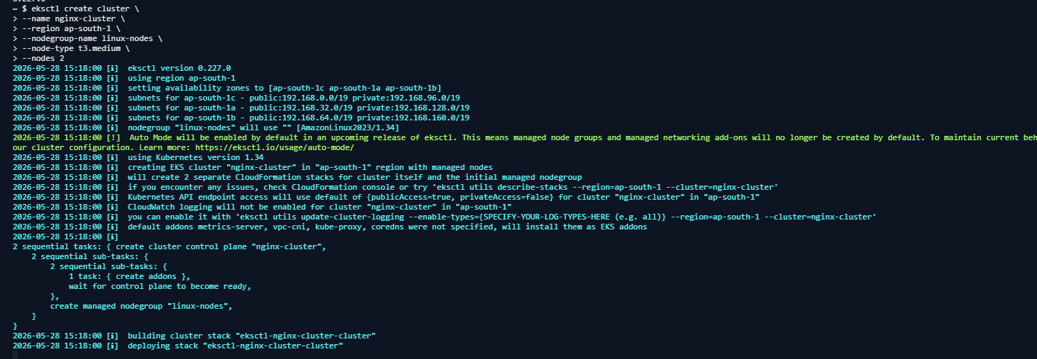

Step 4:

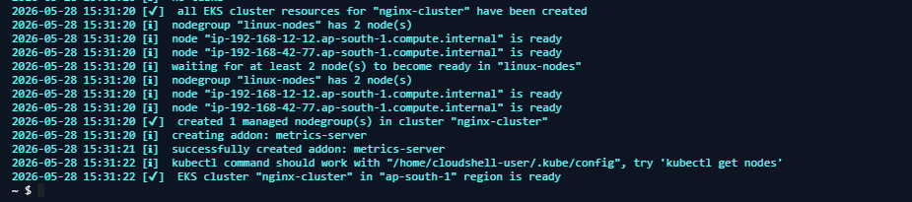

Step 5:

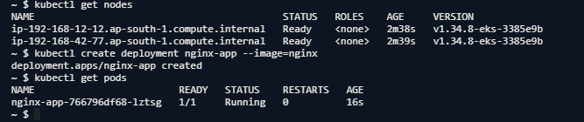

Step 6:

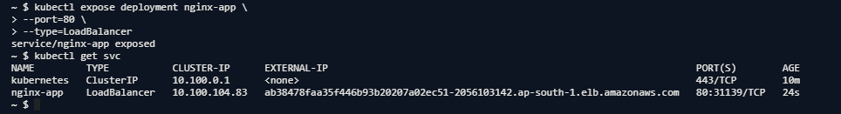

Step 7:

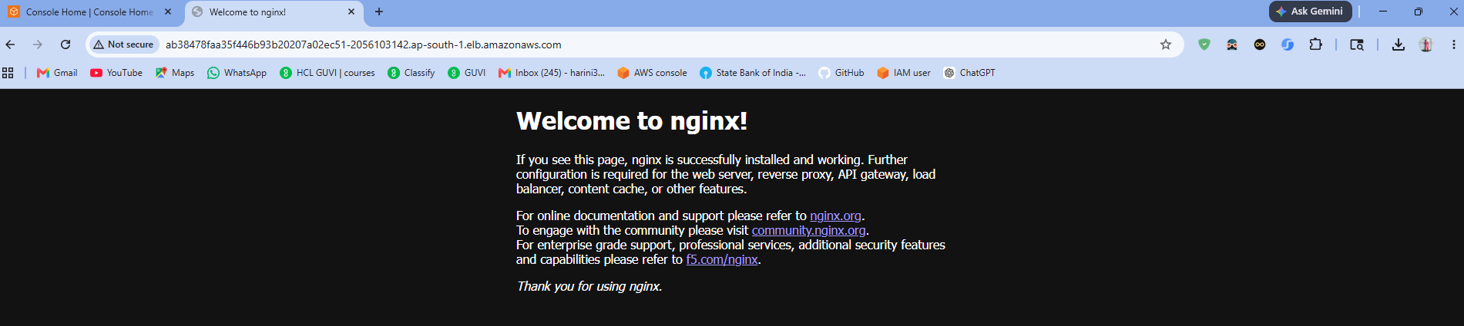

Step 8:
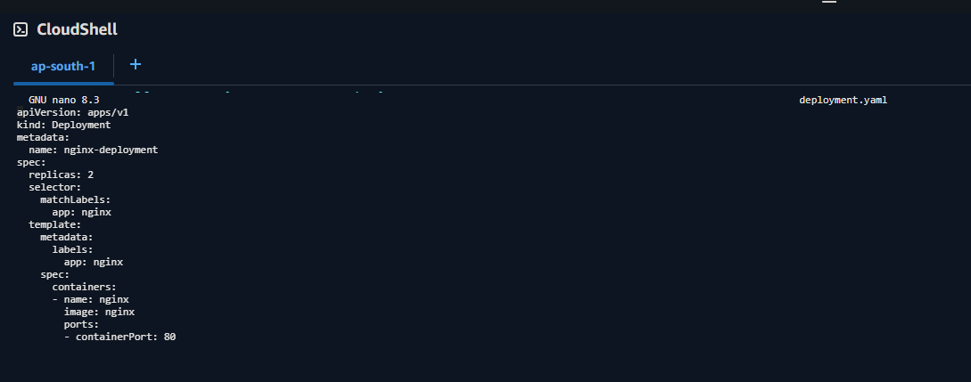

Step 9:

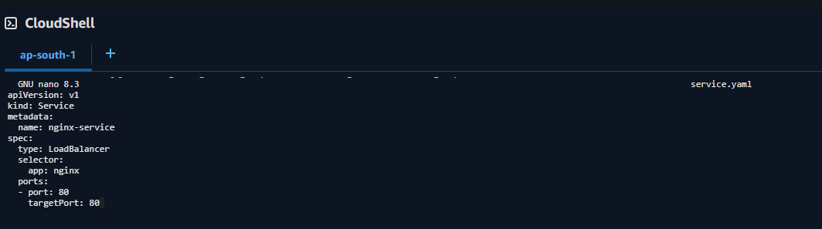

Step 10:

